1795 shows the area almost completely undeveloped. The Oakbrook itself forms the boundary between the Township of Nether Hallam and that of Upper Hallam.
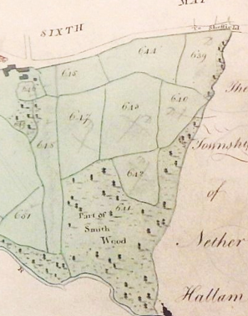
Field 639 was called Horse Pasture, 640 was Colley Pits, 642 was Little Meadow, 643 the Far Field and 647 the Far Meadow. These were all owned by the Duke of Norfolk and tenanted by John Downing. Field 544 was also owned by the Duke but tenanted by John Ibbotson who lived in the house on the far left. Field 644 was named Far New Lands, and 645 New Lands.

By 1851, there is an Oakbrook House on the other side of the Oak Brook. The land on which Oakbrook would be built is still just fields. The house was occupied by Rhodes Marriott and his French wife Frances. It is said that he was once coachman to Joseph Levick of Endcliffe
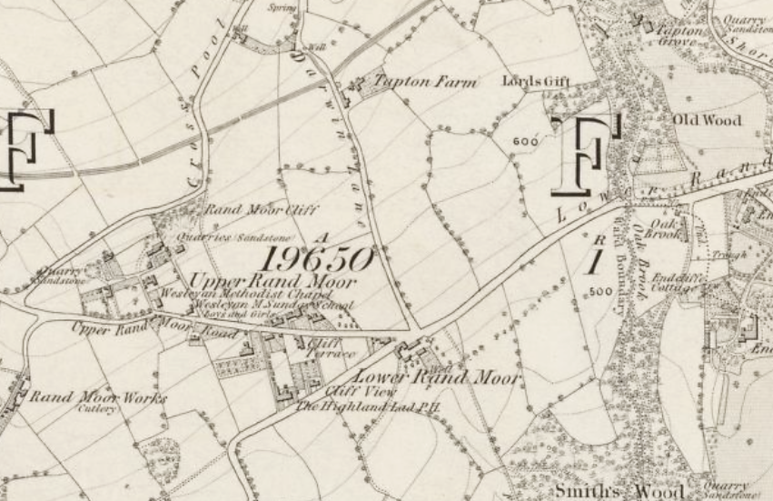

In 1859 there was controversy about Fulwood Road in the Oakbrook area. Technically it was in Ecclesall which included Nether Hallam, but the road had historically had been maintained by the ratepayers of Nether Hallam, who decided it was no longer to be their responsibility. As a result, the road was said to be almost impassable in that area. The Sheffield Independent reported on 18th December 1859
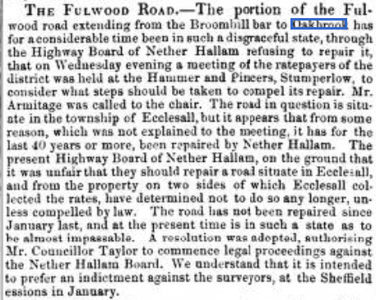
By 1861, however, the problem seems to have been resolved and Mark Firth and his wife were living in Oakbrook House. By August of that year they were hosting their annual children’s entertainment at Oakbrook. On 15th August it was reported that the teachers and school children from the South Street Chapel Sunday School had been invited for the afternoon. They had all assembled in the Eldon Street schoolroom at 13.30 and walked in procession up to Oakbrook which they reached at 14.45. They sang in front of the mansion. The children then
“ ……. dispersed themselves through the extensive grounds and were soon engaged in every species of healthy recreation. After enjoying themselves for two hours they willingly obeyed the call to partake of tea and buns provided for them.
At intervals during the afternoon, the band played a series of lively airs for them to the great enjoyment of those assembled. As evening began to draw near, the company assembled in front of the mansion where they sang the National Anthem, the Doxology (a short hymn of praise to God) and other pieces, and forming a procession returned to school, arriving at about 21.30 after spending an afternoon of most unmixed enjoyment, not the less so as resulting from the spontaneous generosity of Mr Firth.”
In August 1867, the South Street Chapel children were joined by those from Broomhill. In all 950 attended including the teacher. There were also other invited guests, so the number must have been well over a thousand. It seems as though this was a regular event.
As well as being a place for children’s entertainment, Oakbrook had, throughout the 1860 and 1870’s, become a meeting place for several nationally powerful figures. The Minister for War, Sir John Pakinton met with Mr Firth and many other local dignatries at Oakbrook in 1867.
I imagine that these were negotiations concerning armaments for the Government.
It is well known that Mark Firth entertained royalty at Oakbrook during the Royal visit by the Prince of Wales and his wife in 1875. Here is the medal which commemorates the same. Newspapers of the time reported the enormous crowds that lined the streets, both outside Oakbrook and all the way to Sheffield.
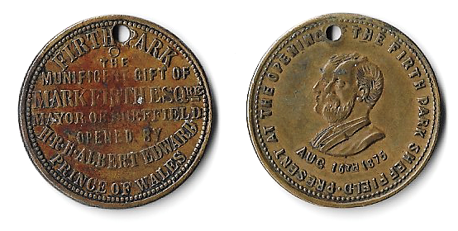

A special piece of dance music was composed by a Sheffield musician, Charles Harvey to commemorate the Royal visit and was played at the Ball given in their honour. It was called “The Oakbrook Galop”.
The galop is a shortened form of galoppade. It is a fast dance played in 2/4 time, and named after the fastest running gait of a horse. The dancers stand in the closed position as they would in a waltz and the step combines a glissade, (glide) with a chassé (3 steps where one foot chases the other) on alternate feet.
The Prince of Wales was not the only member of the royal family to visit Oakbrook. Prince Leopold also visited Oakbrook in October 1879. The Oakbrook Galop was again played at the Ball to welcome him. The music was to prove very popular in and around Sheffield and the sheet music reached a 4th edition.
Prince Leopold so much enjoyed his visit that he gave Mrs Firth an engraved gold pendant when he was leaving Oakbrook. The pendant was embedded with valuable stones, surrounded by pearls. The central stone was a Carbuncle and the four other stones were described as being fine examples of Lapus Lazuli.
Other royalty was also entertained in August 1879, when the Crown Prince of Sweden and Norway was served breakfast at Oakbrook.
Mark Firth died in 1880 and the funeral cortege left from Oakbrook. This is how it was described in the Sheffield Daily Telegraph of 3rd December 1880.
“We are to leave Oakbrook at 11 o’clock. More than an hour before that time the Ranmoor road begins to proclaim the sorrowful business of the day. It is at all times a favourite place of resort, but there are more people about in the early hours than are wont to be seen on the 2nd December. They come singly and in twos and threes, and they pass not the massive gates which guard the entrance to Oakbrook. A little later private carriages come up with their blinds drawn, then follow a body of Independent ministers, a goodly company of Wesleyans and New Connexion Methodists, and after them a long string of carriages which contain the Mayor and Ex-Mayor and members of the Corporation and borough officials. Close on their heels are the Worshipful Company of Cutlers, headed by the Master Cutler, the chaplain and the law clerk, with the beadle of the company on the box with the driver. By this time the magistrates have taken their places, and the Church Burgesses, the Town Trustees and the council and professional staff of Firth College with the members of the School Board have filled up the gaps in the procession which were left for them. The line of equipages is attenuating. As each representative body is driven up, the Chief Constable, on horseback, directs the members to their place. Everything is done in good order, and very quietly and quickly, and without the slightest confusion. Behind the two mounted policemen are some 800 workers, all sombrely clad as mourners are wont to be in England. They had assembled at 9 o’clock in the morning at the Norfolk Works: thence they marched to Endcliffe Vale, from which, at a given time, they passed out to take the place of honour assigned to them. Conspicuous among the arrivals are the Right Hon. the Earl of Wharncliffe, Sir Edward Watkin Bar{one}t M.P., the Chairman and other officials and directors of the Manchester Sheffield and Lincolnshire Railway, who are here to mourn the loss of a valued colleague on the board. Here too are both the Borough Members – The Right Hon. A. J. Mundella and Mr C. S. Wortley. The clergy of the Church of England, who take their places a little later, are distinguished by their academic robes. Long ere this, the hearse, with its nodding plumes, drawn by 4 horses with their sombre trappings, has passed inside the gates, followed by the private carriages which are to be occupied by the mourners, the friends invited to the house, the officiating clergy and the deceased’s executors, and his medical attendants. While we have been waiting, the bells of St John’s Church send forth their muffled peals, and these are answered by kindred sounds wafted from the town, while, now and again, the silence between the peals is broken by a knell which seems to come Wesley College-wards.
All these sounds are singularly distinct this morning, everything is so quiet and calm. Not a breath of wind ruffles the leafless boughs; the spectators speak in subdued tones; the very horses forget to champ their bits, or to paw the ground impatiently with their feet. Messrs Gole’s attendants do their directing with great efficiency and without any noise or fuss, while the police, with equal taste, are seen and not heard. Thus it is that the solemn sound of the bells breaks upon our ears undisturbed by the Babel of bawlers or the discordant cries of ill-directed subordinates. For a great public funeral with a crowd reaching from Broomhill to beyond Ranmoor Church, there surely never was a gathering of such magnitude conducted in such seemly silence as this. As a private internment was not possible, it was well that the public funeral should be conducted with such orderly quietude as made the gathering, beyond its magnitude, almost as silent as if it had been confined to the family and intimate friends of the deceased.”
The 1893 OS map of the area shows the new Oakbrook House, the home of the Firths, with the old house named Oakbrook on the previous map becoming known as Oakbrook Farm. The brook has been diverted to form a pond, and there are ornamental grounds with a fountain. The brook itself appears to have been culverted for a short distance.
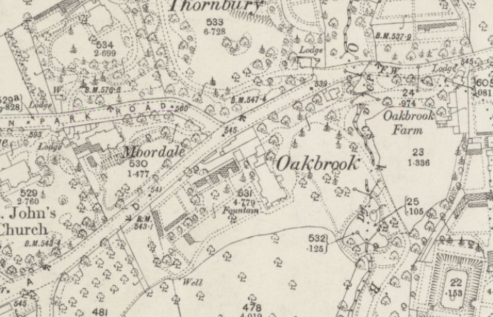

After Mark Firth had died of a stroke, his widow, Caroline, lived on at Oakbrook until her death in 1894. There was then a sale of the house contents. The sale spread over 3 days and included a collection of over 1,000 books, paintings and objects d’art, as well as furniture. There were also many cases of fine champagnes including Krug and Moet Et Chandon. Overall, the sale raised over £3,700.
Oakbrook itself was purchased by Mr William Samuel Laycock, previously of Rose Mount Ranmoor. According to the Sheffield Daily Telegraph of 2nd August 1894, Mark Firth’s will gave a life interest in the house to his wife until all their children reached the age of 21. It was then to pass to his second son, Mark Firth. Mrs Firth however had died on 13th July, and the children were all of age, so the house had been put on the market.
This OS map dates from 1903. A boat house has been built by the enlarged pond. Islands have also appeared
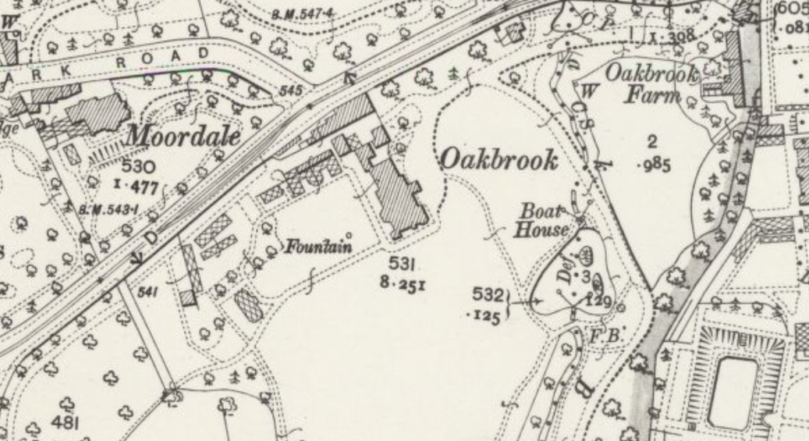

1903 also saw the first reference to an electric car (EV) in Sheffield, which was a 5HP electric Runabout vehicle from the National Vehicle Co of Indianapolis, USA. The licence was granted in Dec 1903 to William Laycock of Oakbrook, Sheffield.
Under the Laycocks, the grounds of Oakbrook were often opened up by Mrs Laycock for the annual Ranmoor Flower Show and Gala and, in July 1909, for the Hallam branch of the Young Helpers League Gala, where there were flat and potato races for children of each sex and a sack race for the boys and with a skipping race for the girls.
Mr Laycock J.P. was a successful businessman making springs needed for the railways, but took little part in public affairs, so Oakbrook only tended to host those organisations patronised by his wife. He died on 2nd March 1916, aged 73, his obituary in the Sheffield Daily telegraph of 3rd March 1916 carried this photograph of him
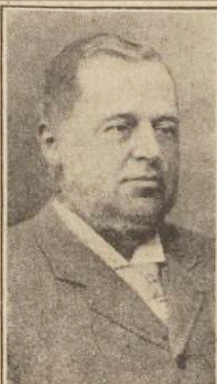
Following his death, the contents of Oakbrook were again advertised for sale. This time the sale was spread over 5 days.
The house however had a full description. It was to be sold by auction by Messrs W. H. & J. A. Eadon at their sales rooms in St James Street in Sheffield on Tuesday 11th July 1916 at 4.30 p.m. This is how Oakbrook was advertised
“Ranmoor Sheffield with the extensive Pleasure Grounds, Gardens, Park, Woodland, Ornamental Water, Lodges. Motor Houses, Conservatories, Greenhouses, and Farm Buildings recently occupied by the late owner.
The house is a handsome structure of dressed stone, occupying a commanding position with south and west aspects, and is approached by carriage drives from Fulwood and Riverdale Roads, with an Entrance Lodge to each. The House contains :-
A SUITE OF FINE RECEPTION ROOMS
comprising Dining Room 30ft x 19 ft. Drawing Room 32 ft x 19ft. Billiard Room 25 ft x 20 ft. Morning Room 22ft x 17ft and Library fitted with oak bookcases 17½ ft x 14ft.
Spacious Entry Hall and corridors, Cloakroom, Lavatory, Telephone and Lift Rooms, Three large safes, Well-fitted kitchen, Servants Hall, Pantry, and other domestic offices.
ON THE FIRST FLOOR, which is approached by the IMPOSING PRINCIPAL STAIRCASE, as well as a secondary staircase and AUTOMATIC LIFT, ELEVEN BED and DRESSING ROOMS (including a self-contained Nursery Suite) four Bath Rooms and Linen and other Store Rooms.
ON THE SECOND FLOOR four Servants’ Bedrooms, Box Room etc.
In the Basement extensive and well-lighted cellars
The house is equipped on the most lavish scale with every appointment which comfort and luxury can suggest. The decorations are of an expensive character, the parquet floor and painted ceiling of the Drawing Room being specially worthy of note.
Adjoining the house is a well-equipped Laundry, also Coal and Boot Houses, Game Larder, etc, Motor Garage with repairing pit and glazed Washing Shed.
The extensive Gardens and Grounds comprise formal Gardens, Shrubberies, Park and Woodland, Kitchen Gardens, Orchards and Ornamental Water, handsome Conservatories, Vineries, Peach, Melon Tomato and other greenhouses and forcing pits.
At a distance from the House are a foreman’s cottage, barn, horse-box and stable with accommodation for 5 cows, pigsties, dog kennels etc.
FREEHOLD GROUND RENTS amounting to £140 per annum secured on Residential Property in Riverdale Road will be included in the Sale.”
The new purchaser was Arthur Wightman J.P. (probably as a nominee for someone who wished their identity to remain anonymous). The House was offered up as a hospital for wounded officers following a War Office appeal to the then Mayor for better provision for the officers in Sheffield. The offer was rent free and was to last for the duration of the war. Alterations costing £4,000 were needed and the sum was quickly raised from wealthy citizens and businesses throughout Sheffield. The Sheffield Independent of 31st March 1917 reported that the works were shortly to be commenced, and that the provision would free up beds in the city hospitals for ordinary soldiers.
Work must have proceeded very quickly because the first casualties were received in May 1917. In January 1919 a concert to entertain the patients was put on, but they must have been discharged within the following few months Sadly there is a report of an RAF officer Lt H. R. Dyson who died of pneumonia and pleurisy which he had contracted whilst on leave in Sheffield at what became known as Oakbrook Hospital towards the end of November 1918 shortly after the end of the war. Earlier, in August of that year, Major Ernest William Longden also died of his wounds at Oakbrook.
On 10th May 1919, the news broke in the Sheffield Daily Telegraph that the Nuns of Notre Dame who ran a convent school in Cavendish Street were expanding their school which took both Catholics and Protestant family children on a day and boarding basis, had agreed to buy Oakbrook. Initially the house would just be for the nuns and operate as a Community House, but it was anticipated that the school would move there in the next few years.
Shortly afterwards, in August 1919, a garden party was hosted at Oakbrook in aid of St Marie’s War memorial Trust, where the crowd were entertained by the Sheffield Imperial Recreation Band. The Sheffield Daily Telegraph of 18th August shows a Miss Margaret Bingham, an elocutionist ‘entertaining’ the audience.
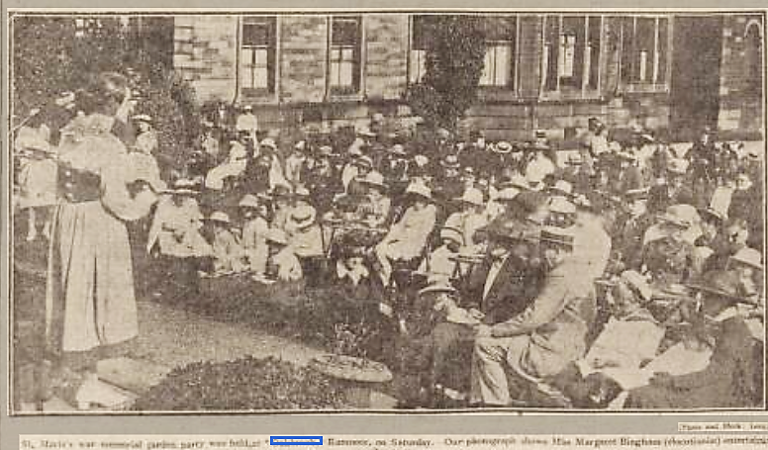
Another photo appeared in the 18th August edition. This time the audience are appreciating a Spanish Dance.
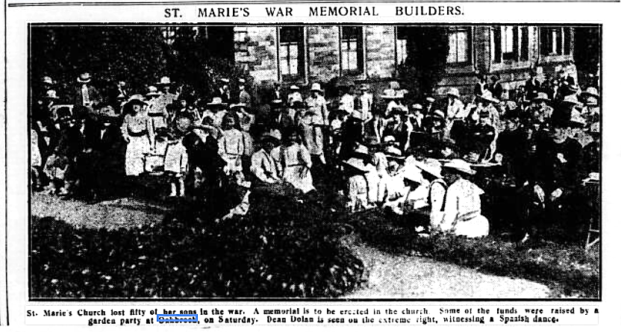

By 1922, another OS map was published. The buildings previously fronting the main road have gone, and there is only one island in the pond. Minor changes to outbuildings have also occurred but otherwise the house has seen little external change. Internally however it has become a religious house as the map acknowledges
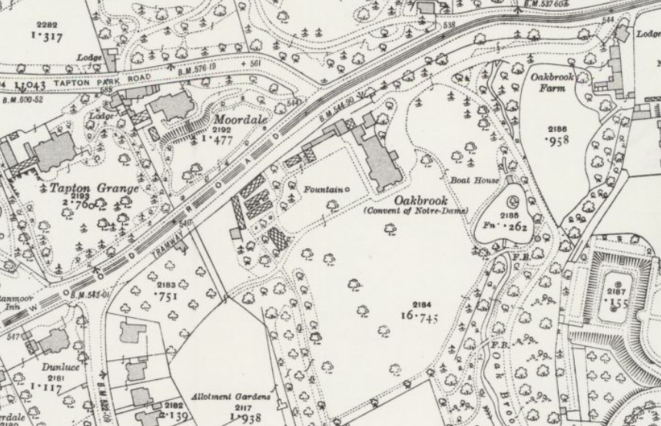
The above gives a brief history of Oakbrook House up to the time of the coming of the nuns, there is much more to discover, but hopefully this gives a basic skeleton for future research. In particular I am going to look at this entry from Sheffield Archives which as a plan dated 1813, the next time I visit.
FC/P/SheD/361S
Alternative Reference number | FC SheD 361 S
Title | Sheffield: Fulwood Road. Smith Wood and a farm, now the grounds of Oakbrook

Alan Crutch
Fulwood 23rd June 2026

